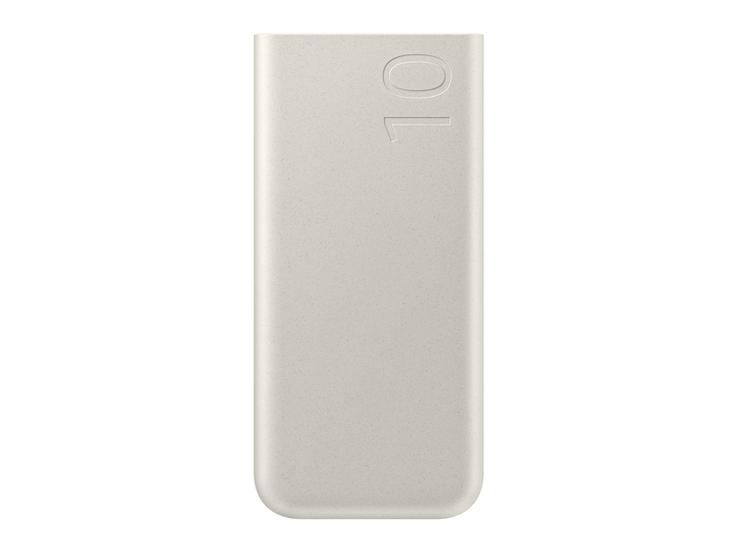

[Accessible Carousel](https://www.samsung.com/us/mobile/mobile-accessories/phones/25w-10000-mah-battery-pack-beige-eb-p3400xuegus/)

[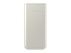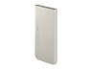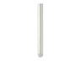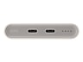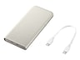](javascript:;)

**25W 10,000 mAh Battery Pack, Beige**

**EB-P3400 /EB-P3400XUEGUS**

4.0 out of 5 stars, average rating value. Read 20 Reviews. Same page link.

4.0

(20)

Write a review

Share your product experience

* • Power up at a moment’s notice. Whether it’s your phone, buds or both, you can quickly charge whenever you need with a fast and powerful battery pack.\*

**Color**

[[](https://www.samsung.com/us/mobile/mobile-accessories/phones/25w-10000-mah-battery-pack-beige-eb-p3400xuegus/)](https://www.samsung.com/us/mobile/mobile-accessories/phones/25w-10000-mah-battery-pack-beige-eb-p3400xuegus/" \t "_self)

[Get it by Dec. 23](https://www.samsung.com/us/mobile/mobile-accessories/phones/25w-10000-mah-battery-pack-beige-eb-p3400xuegus/" \t "_self)

https://image-us.samsung.com/SamsungUS/New/truck.png?$default-png$

Get it by Dec. 23

**25W 10,000 mAh Battery Pack, Beige$34.99**

https://image-us.samsung.com/SamsungUS/home/store-locator/storepickup.png?$default-png$

**In-Store Pickup:Select Store**

Pickup unavailable for this ZIP

https://image-us.samsung.com/SamsungUS/home/vc2-0/truck-icon.png?$default-png$

**Delivery for:10001**

Get it by Dec. 23

Total

**$1.46**/mo for **24** mos at **0%** APR⊕

**$34.99**



**Log in to earn up to 3 points per $1**

[**ADD TO CART**](javascript:;)

[**WHERE TO BUY**](https://www.samsung.com/us/mobile/mobile-accessories/phones/where-to-buy/25w-10000-mah-battery-pack-beige-eb-p3400xuegus/EB-P3400XUEGUS)

Supported payment types:

Credit Cardhttps://image-us.samsung.com/SamsungUS/home/tv-pdp-conf/paypal-logo.png?$default-png$https://image-us.samsung.com/SamsungUS/home/tv-pdp-conf/amazon-pay.png?$default-png$https://image-us.samsung.com/SamsungUS/home/tv-pdp-conf/icn_google-pay-mark.png?$default-png$https://image-us.samsung.com/SamsungUS/home/tv-pdp-conf/samsung-financing.png?$default-png$

**Frequently Bought Together**

These accessories and related devices are popular with customers who bought this product.

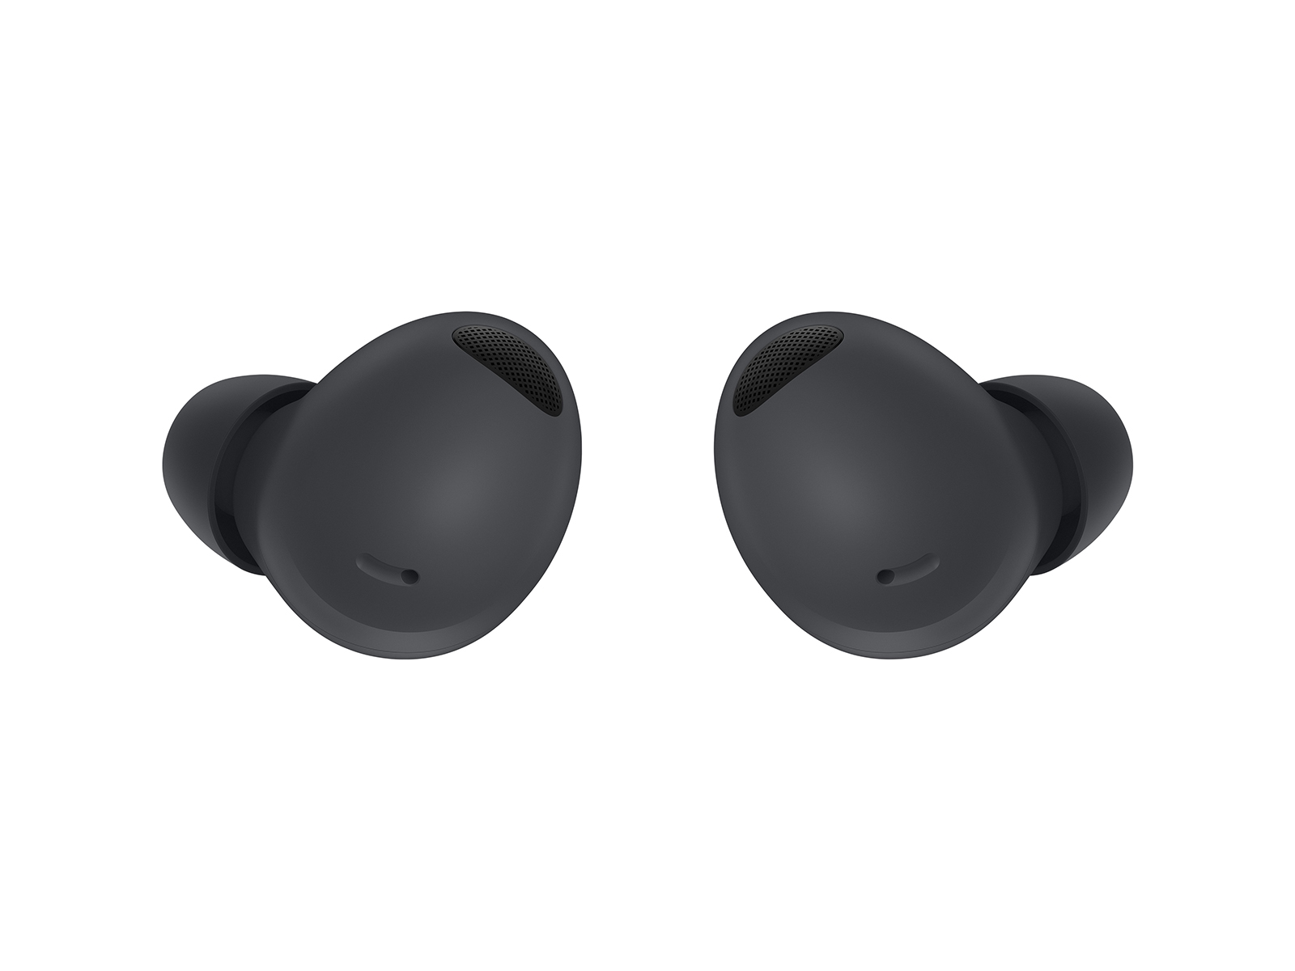

**Galaxy Buds2 Pro, Graphite**

**$149.99** ~~$229.99~~

**Get it by Dec. 18**

[Learn more- Galaxy Buds2 Pro, Graphite](https://www.samsung.com/us/mobile/audio/headphones/galaxy-buds2-pro-graphite-sm-r510nzaaxar/)

https://image-us.samsung.com/SamsungUS/palette/icon/Shopping-Cart_EmptyDT.png?$default-png$**EXTRA $80.00 SAVINGS**

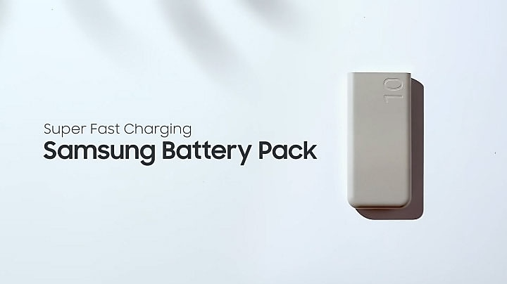

**Buying online has never been easier or safer**

**Free Shipping**

**Order with confidence. Safe, contact-free two-day delivery.**

[**LEARN MORE- Free Shipping**](https://www.samsung.com/us/support/order-faqs/#questionID20)

**Exclusive business savings**

**Enjoy exclusive volume discounts on eligible accessories, 0% Samsung Business Financing and limited time instant savings.**

[**LEARN MORE**](https://www.samsung.com/us/business/shop/all-deals/watches-audio-accessories-deals/)